**Assignment Tasks**  
**Question 1:** Imagine you are tasked with retrieving a list of all restaurants and their menu items. Some restaurants may not have any menu items yet. Write an SQL query that performs a LEFT JOIN between the **"Restaurant_info"** and **"MenuItems"** tables to achieve this. Your query should include the restaurant name and the name of the menu items, if available.

**Question 2:** Extend the previous query to include the restaurant's contact number and the availability status of each menu item. If a restaurant does not have any menu items, display **"No Menu Items"** in the menu item column.

**Solution:**

1. SELECT A.name AS Restaurant_name, B.name AS Menu_Item

FROM restaurant_info A LEFT JOIN menuitems B

ON A.restaurant_id = B.restaurant_id;

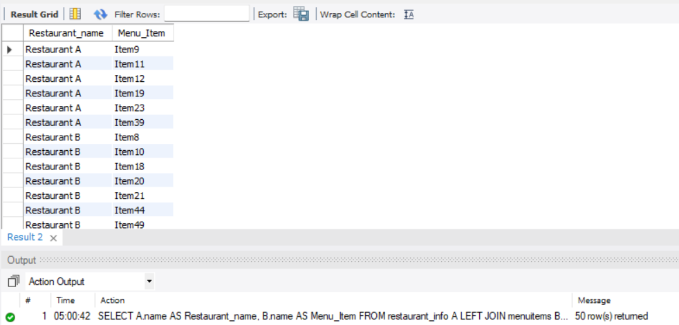

1. SELECT A.name AS Restaurant_name, A.contact_number,

COALESCE(B.name, 'No Menu Items') AS Menu_Item, B.availability

FROM restaurant_info A LEFT JOIN menuitems B

ON A.restaurant_id = B.restaurant_id;

